Name: Nidheesh S
Roll No: 38
Date: 24/11/2023
EXPERIMENT – 8

GREETING WEBPAGE

index.html:

<!DOCTYPE html>
<html lang="en">
<head>
<meta charset="UTF-8">
<meta name="viewport" content="width=device-width, initial-scale=1.0">
<title>Greeting Page</title>
<style>
body {
font-family: 'Segoe UI', Tahoma, Geneva, Verdana, sans-serif;
background-color: #f4f4f4;
color: #333;
text-align: center;
margin: 50px;
}

h1 {
color: #4285f4;
}

p {
font-size: 18px;
line-height: 1.6;
color: #555;
}

button {
background-color: #4285f4;
color: #fff;
font-size: 16px;
padding: 10px 20px;
border: none;
cursor: pointer;
transition: background-color 0.3s ease;
}

button:hover {
background-color: #1a73e8;
}

#video-container {
display: none;
margin-top: 20px;
}

iframe {
border: 0;
}
</style>
</head>
<body>

<h1>Welcome to the Greeting Page!</h1>
<p>This is a simple greeting message.</p>

<button onclick="playRickRoll()">Don't Click Me</button>

<div id="video-container">
<iframe id="rickroll-video" width="560" height="315" src="https://www.youtube.com/embed/dQw4w9WgXcQ?autoplay=1&mute=1" frameborder="0" allowfullscreen allow="autoplay"></iframe>
</div>

<script>
function playRickRoll() {
var videoContainer = document.getElementById("video-container");
var button = document.querySelector("button");

// Hide the button and show the video container
button.style.display = "none";
videoContainer.style.display = "block";
}
</script>

</body>
</html>

OUTPUT:

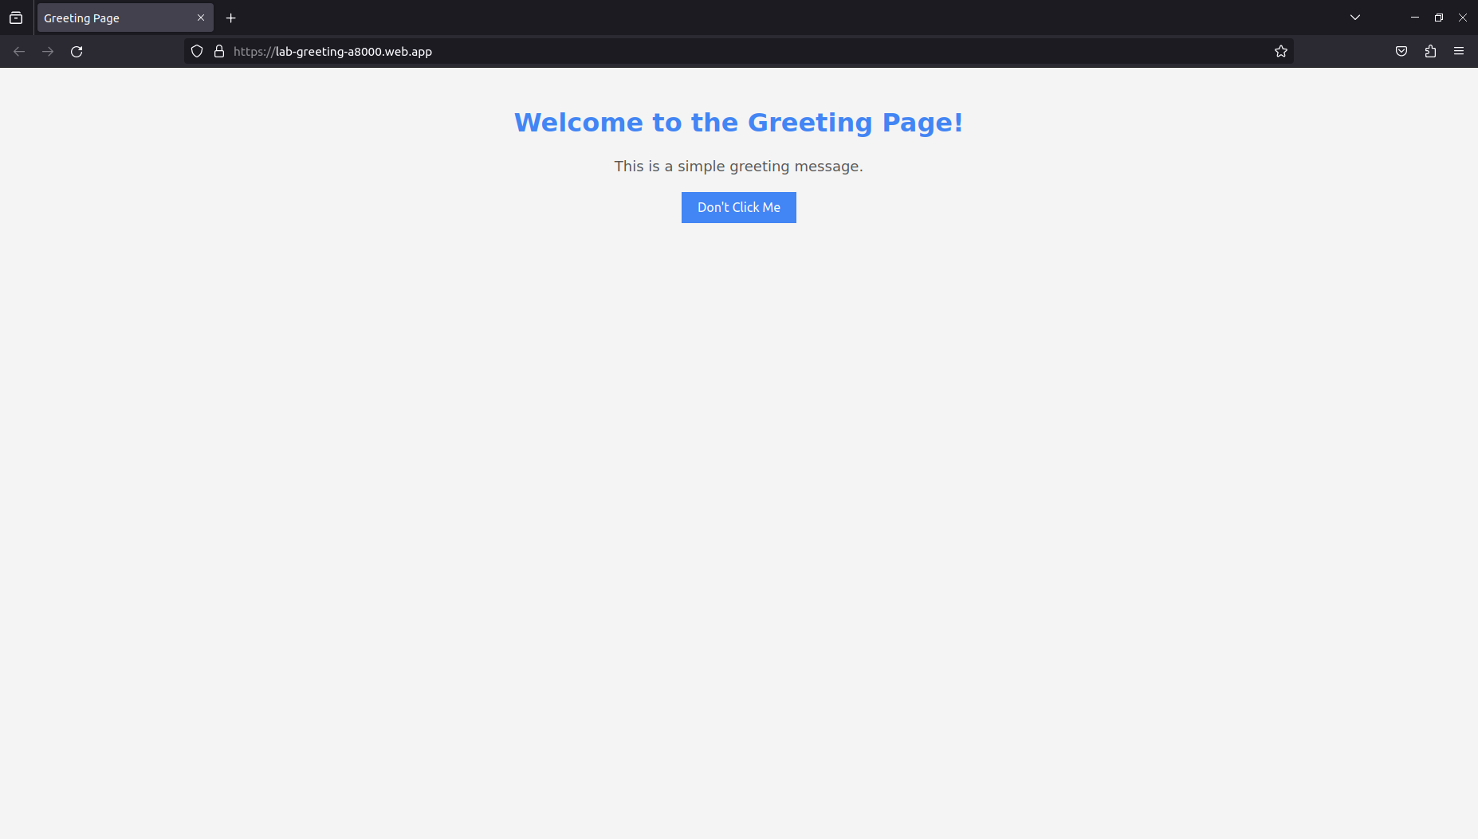
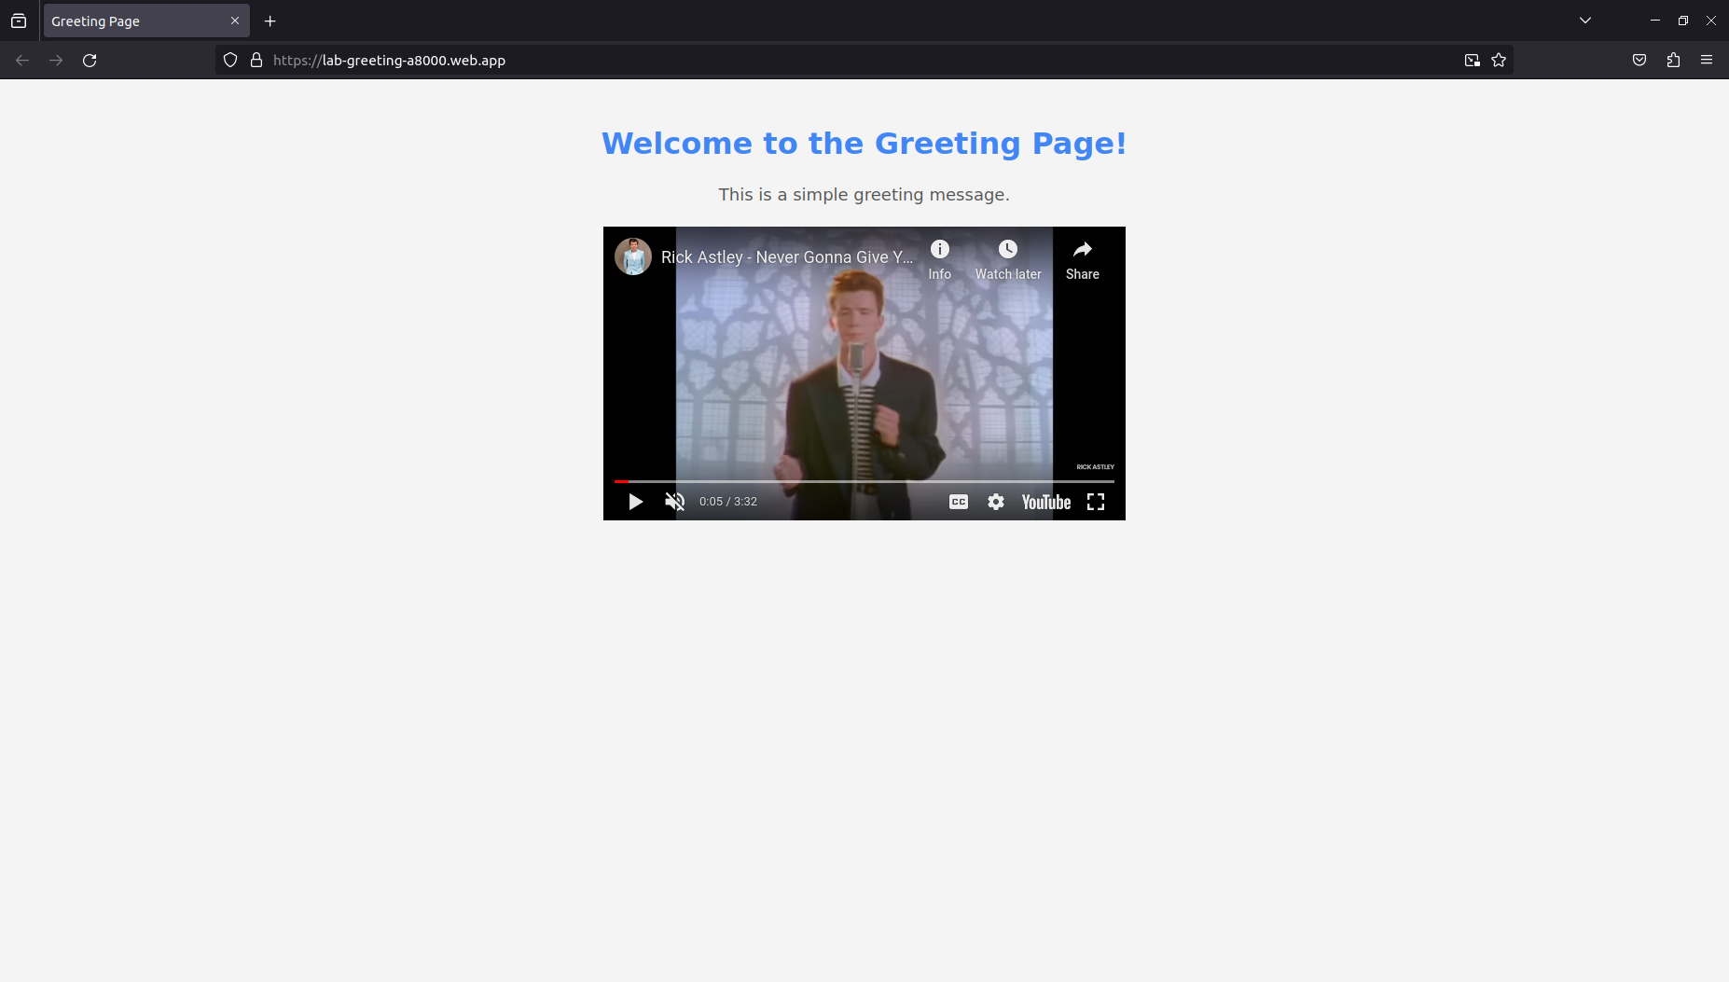
https://lab-greeting-a8000.web.app/

